Yusuf Mert Çınar 02230215068 Computer Programming And Algorithms 1st homework

Exercise 1

•Draw the flowchart that finds the sum of even numbers

smaller than the number of N entered by the keyboard

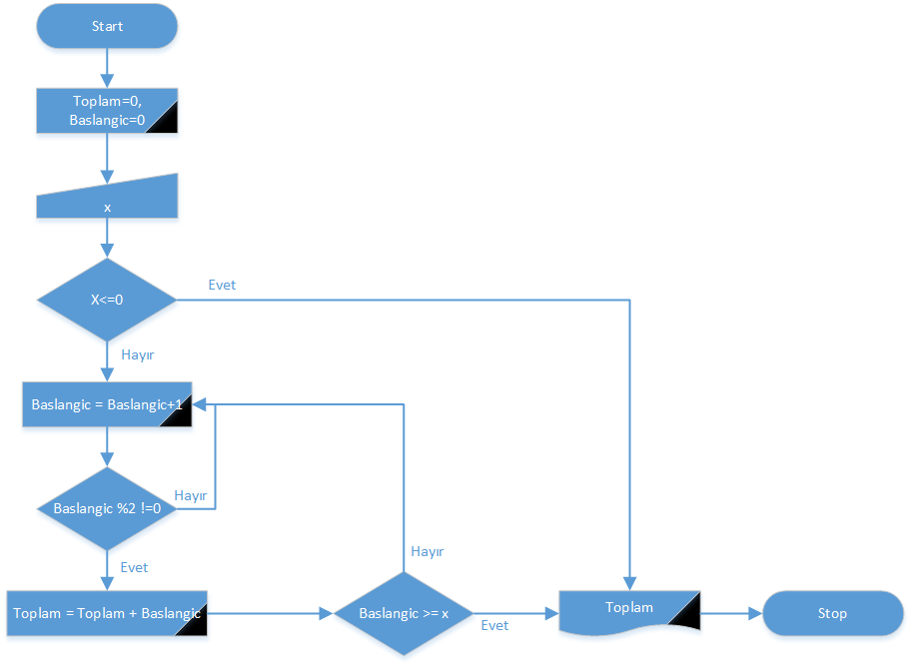

•Draw the flowchart that finds the sum of odd numbers

smaller than the number of N entered by the keyboard

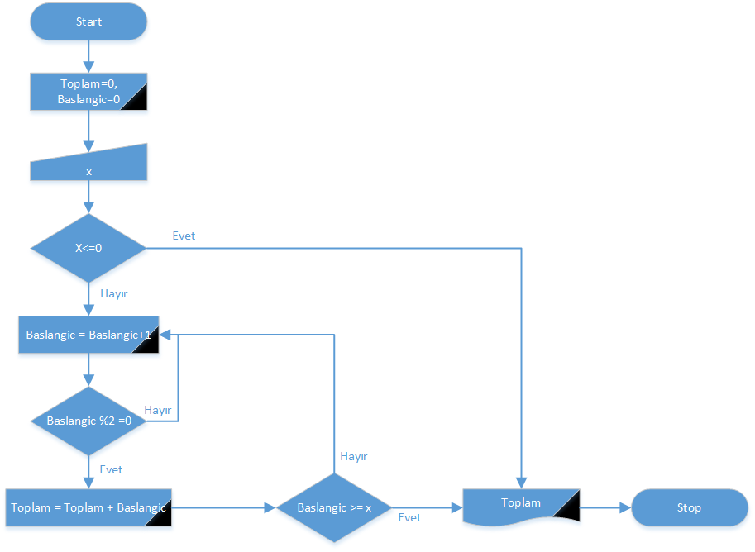

•Draw the flowchart that finds the sum of the series

given below for first N terms. N is entered by the

keyboard. 2+5+8+11+.........

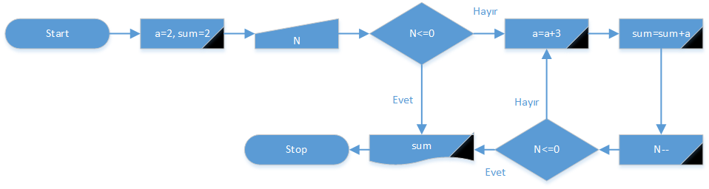

•Draw the flowchart that calculates the result of the

function below for first N terms. N and x are entered

by the keyboard.

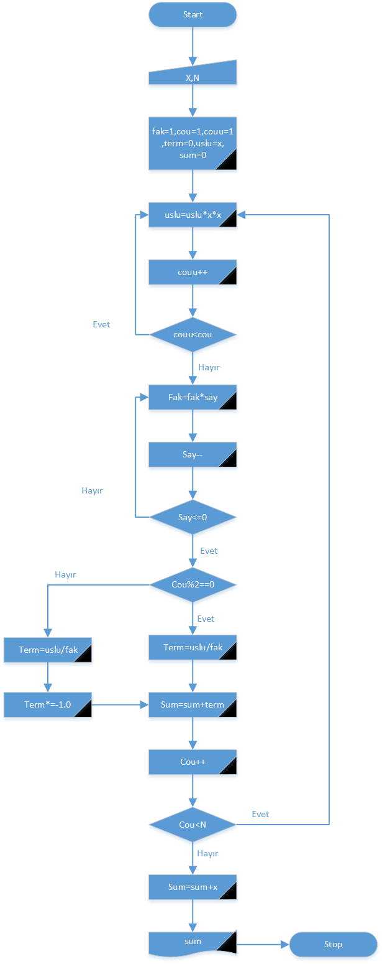

Exercise 2

• Draw the flowchart that calculates the result of the function

below for first N terms. N and x are entered by the keyboard.

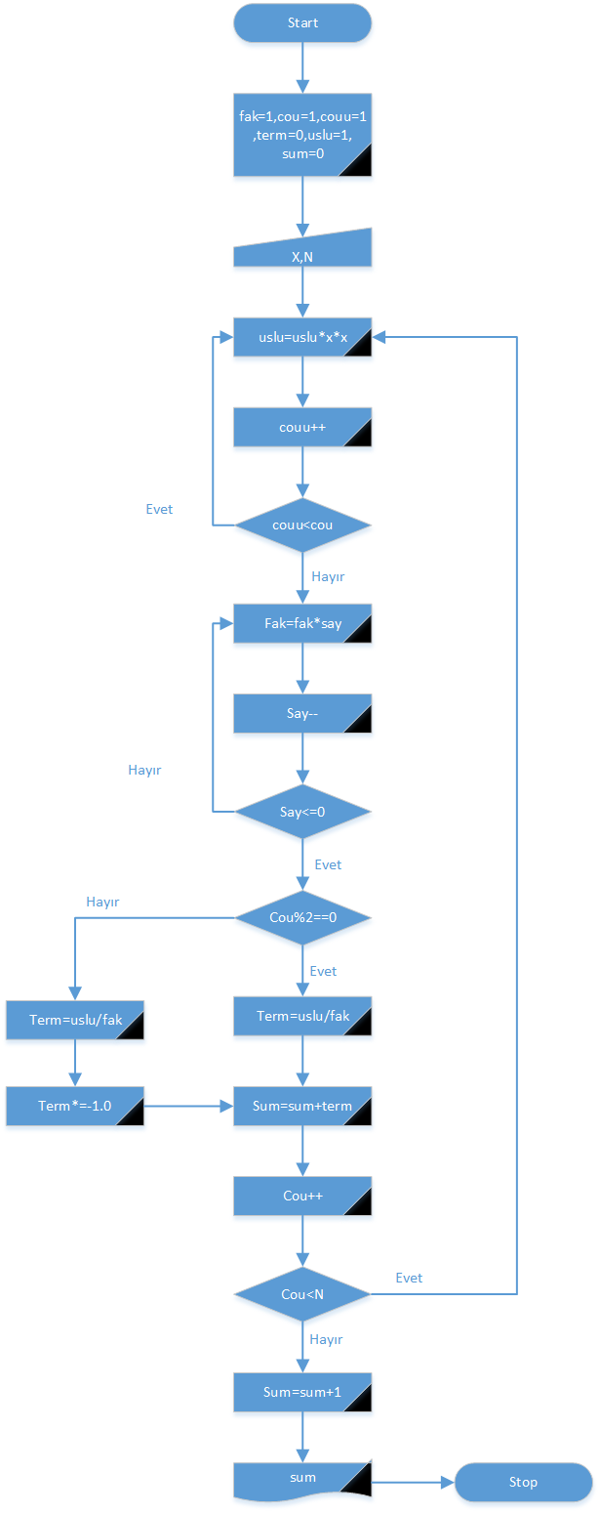

• Draw the flowchart that calculates the result of the function

given below. The program must continue running and want a

new x number after each calculation, until the number of 555

is entered as the value of x. If x=555, then program ends.

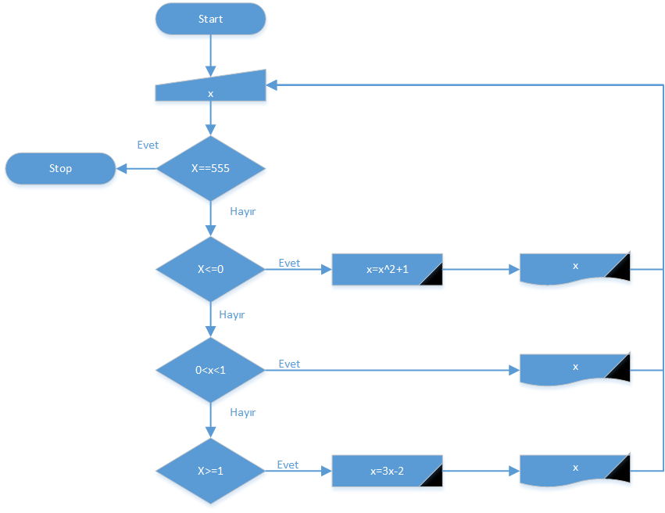

Exercise 3

•Draw a flowchart finding the GCD of two numbers by

using conventional mathematical methods

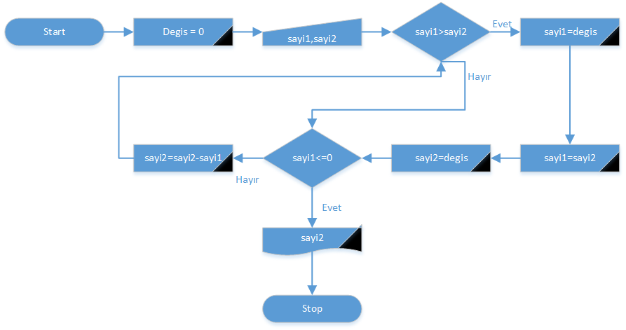

•Draw the flowchart that calculates the result of the

function given below according to x value entered by the

keyboard.

